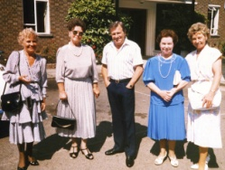
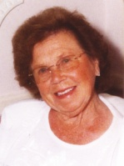
This is a simple 8 page A5 Funeral Programme.
We do not have any templates for more complicated ones and the basic layout of this template can’t be changed in any way.
If you take your time and follow the few simple instructions carefully everything will run smoothly.
This template is designed for Word 2007. It also seems to work fine in Word 2010. It may not work properly in earlier versions of Word or on an AppleMac.
Before you start, you will need to decide on what photos you wish to use. Put them in a folder on your desktop so you can locate them easily. You will need :

5 PORTRAIT style photos and 3 LANDSCAPE style photos

The optimum ratio of the width/height is 4:3. This is the standard on most digital cameras but put simply, a portrait photo is 3cm wide and 4cm tall (or 6cm wide and 8 cm tall etc.) whereas a landscape photo is 4cm wide and 3cm tall.
You may wish to edit and crop photos first in your Photo Editing Software so that any unnecessary background or people are removed and that your loved one fills the photo. If so please try to crop them using this 4:3 ratio. Do contact us if you don’t understand what this means.
When you place the photo into this template it doesn’t matter on its actual size as it will be shrunk to fit in the available space.
Be careful not to try to enlarge images as this will result in a low resolution and the result will be poor.
You also need to have spoken to the person conducting the service to decide on what order things need to go.
The text has been set in either Garamond or Arial and it is best not to try to use a different font unless this is absolutely necessary as this could cause last minute problems.
Please DO NOT add extra text boxes unless you fully understand how Word works as this could cause images to shift or disappear – particularly the background image!
If you make a mistake don’t panic, just use Word’s GO BACK arrow. This is usually at the very top of the screen.
It is unlikely that you will be able to successfully print out this document so you will need to proof read it carefully on the screen.
Once you have finished you need to email the document to us together with your contact details and requirements.
We will then send you a PDF to sign off.
Finally, we suggest you make a copy of this document before you start just in case you need to start again.
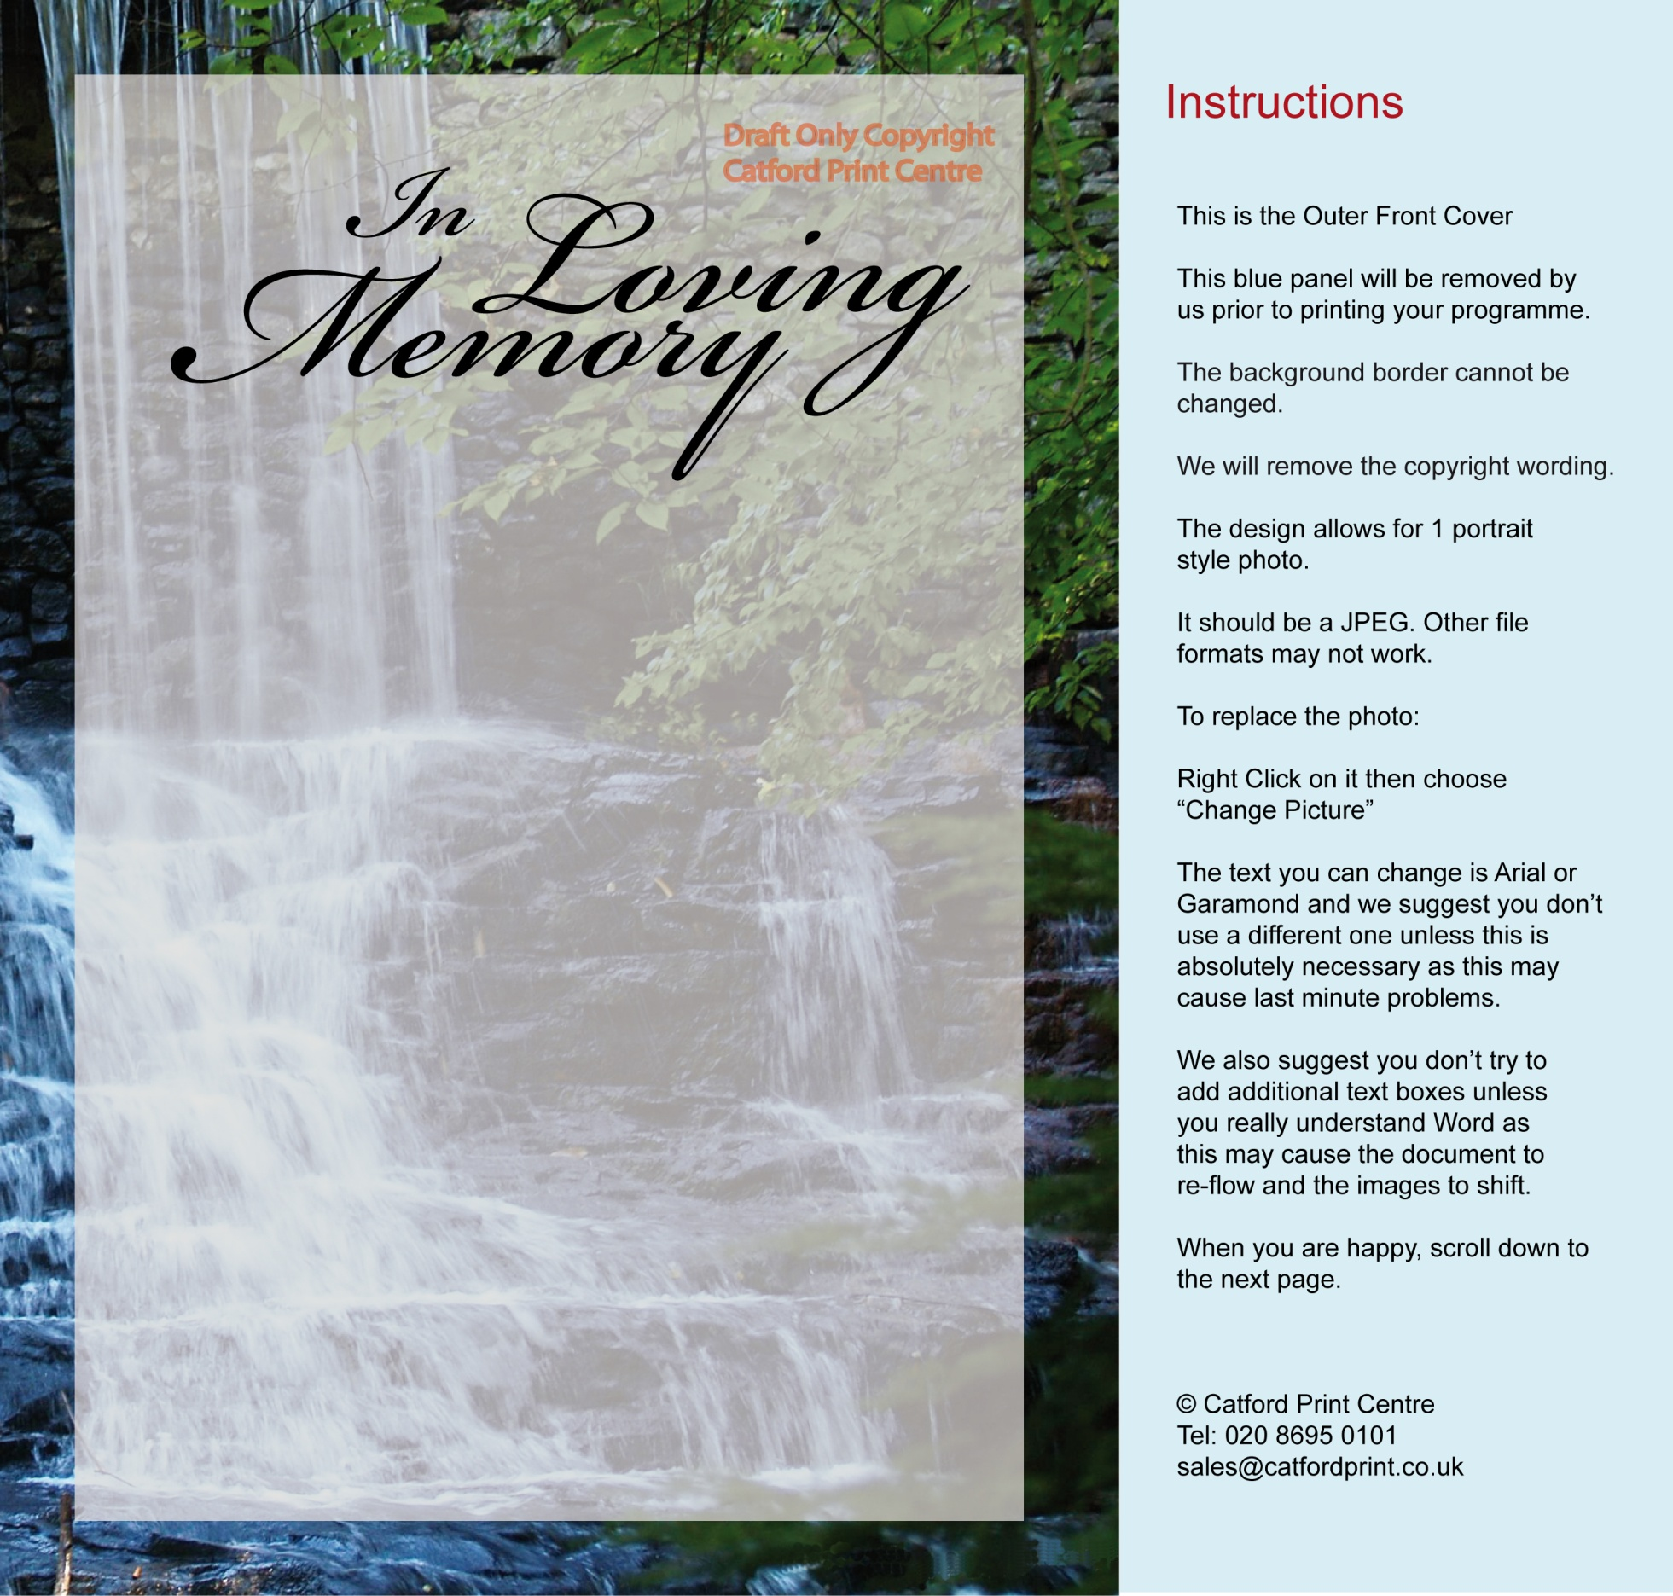
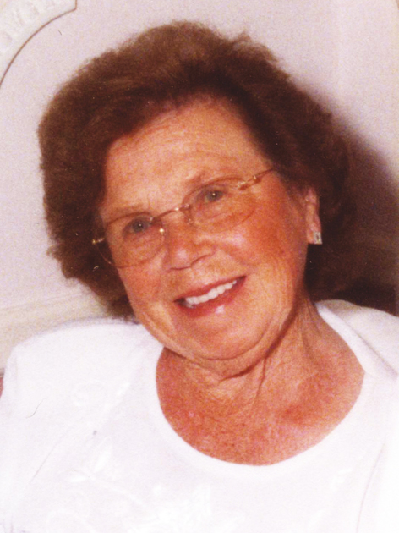
Funeral Service on :
Monday 9th January 2012 at 13.30 hrs
at
Beckenham Crematorium,
Elmers End Road, Beckenham, Kent BR3 4TD
FRANCES CASSIDY JONES
4th September 1921 – 13th December 2011
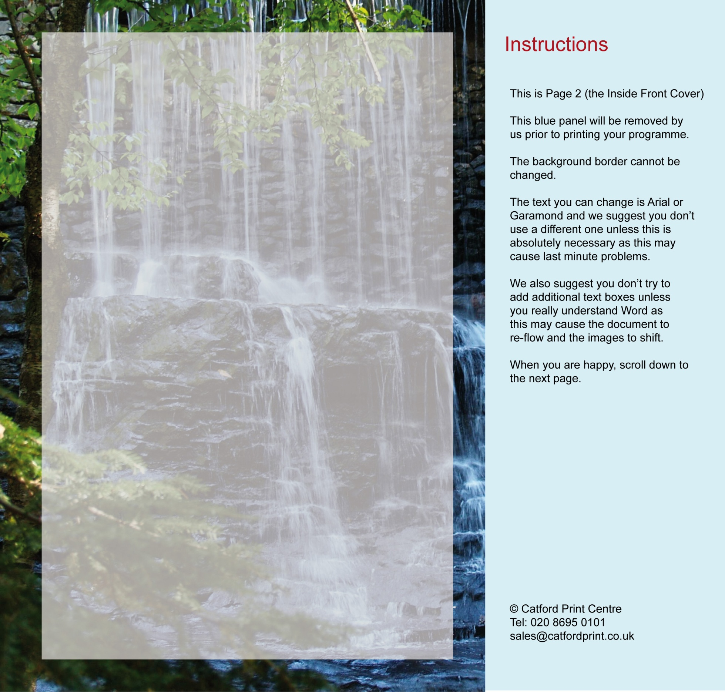
ORDER OF SERVICE
Service conducted by Reverend Jonathan Peterson
~
ENTRY MUSIC

‘Jerusalem the Golden’
~

WELCOME & OPENING PRAYER
~

1. HYMN

‘All Things Bright and Beautiful’
~

FAMILY TRIBUTE

Joseph Mulholland (Son)
Trevor Dubois (Son-in-Law)
~

BIBLE READING

St. John Chapter 14 verses 1-6

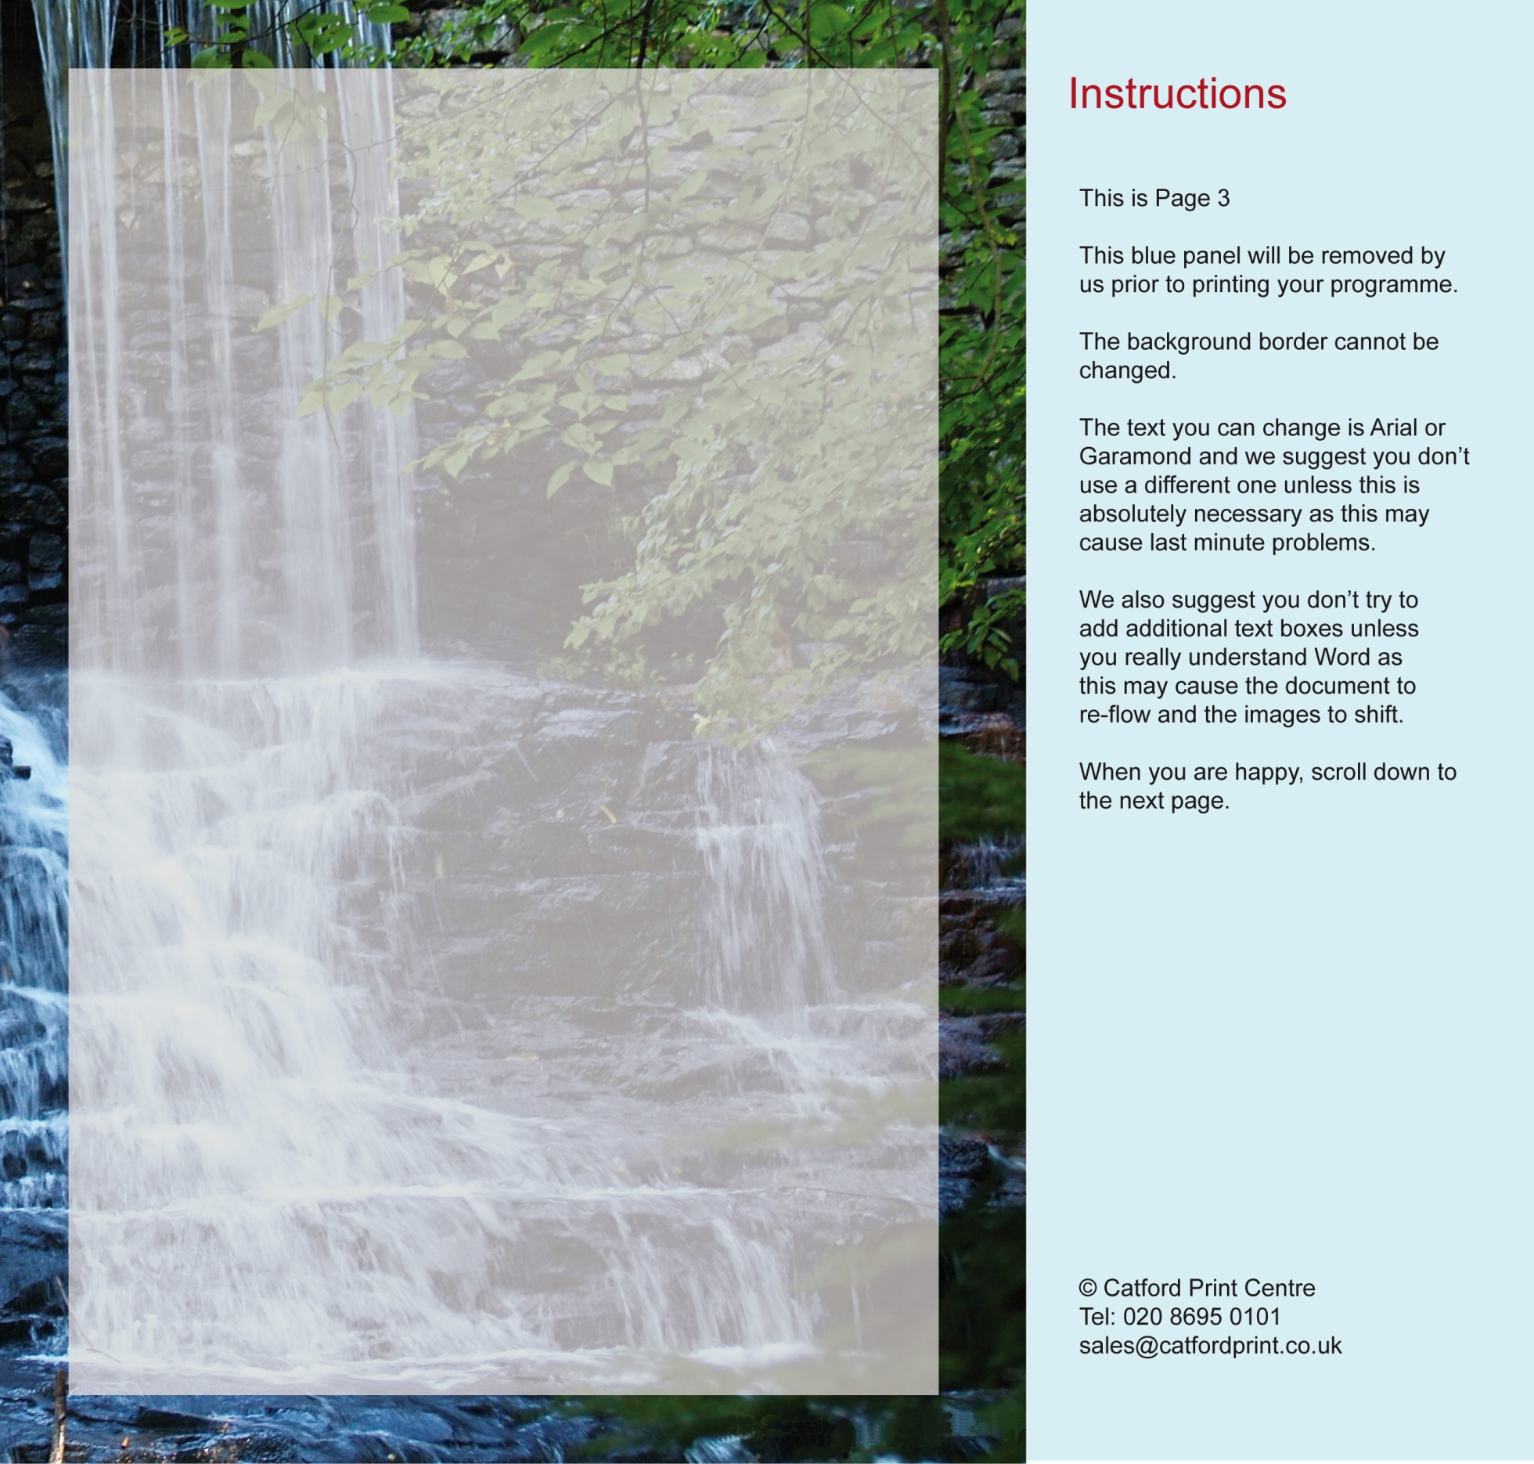
1. Hymn
All Things Bright and Beautiful
All things bright and beautiful,
All creatures great and small,
All things wise and wonderful:
The Lord God made them all.
Each little flower that opens,
Each little bird that sings,
He made their glowing colors,
He made their tiny wings.
Refrain
The purple headed mountains,
The river running by,
The sunset and the morning
That brightens up the sky.
Refrain
The cold wind in the winter,
The pleasant summer sun,
The ripe fruits in the garden,
He made them every one.
Refrain
He gave us eyes to see them,
And lips that we might tell
How great is God Almighty,
Who has made all things well.
All things bright and beautiful,
All creatures great and small,
All things wise and wonderful:
The Lord God made them all.

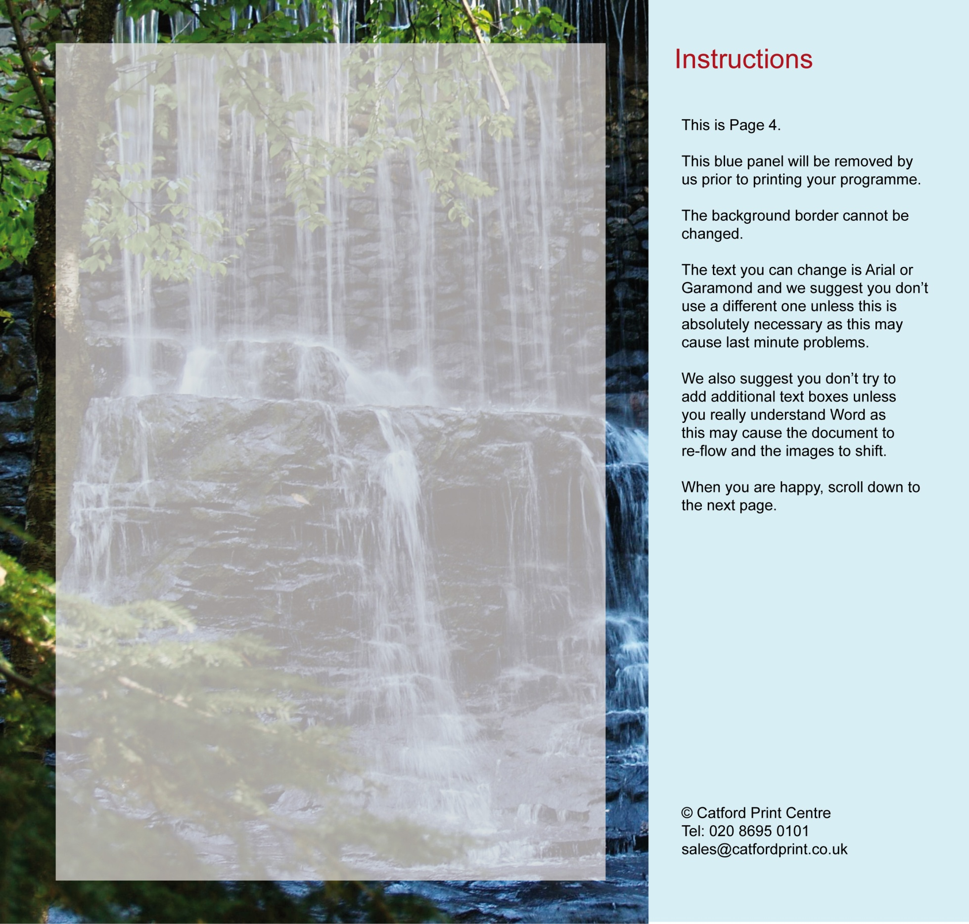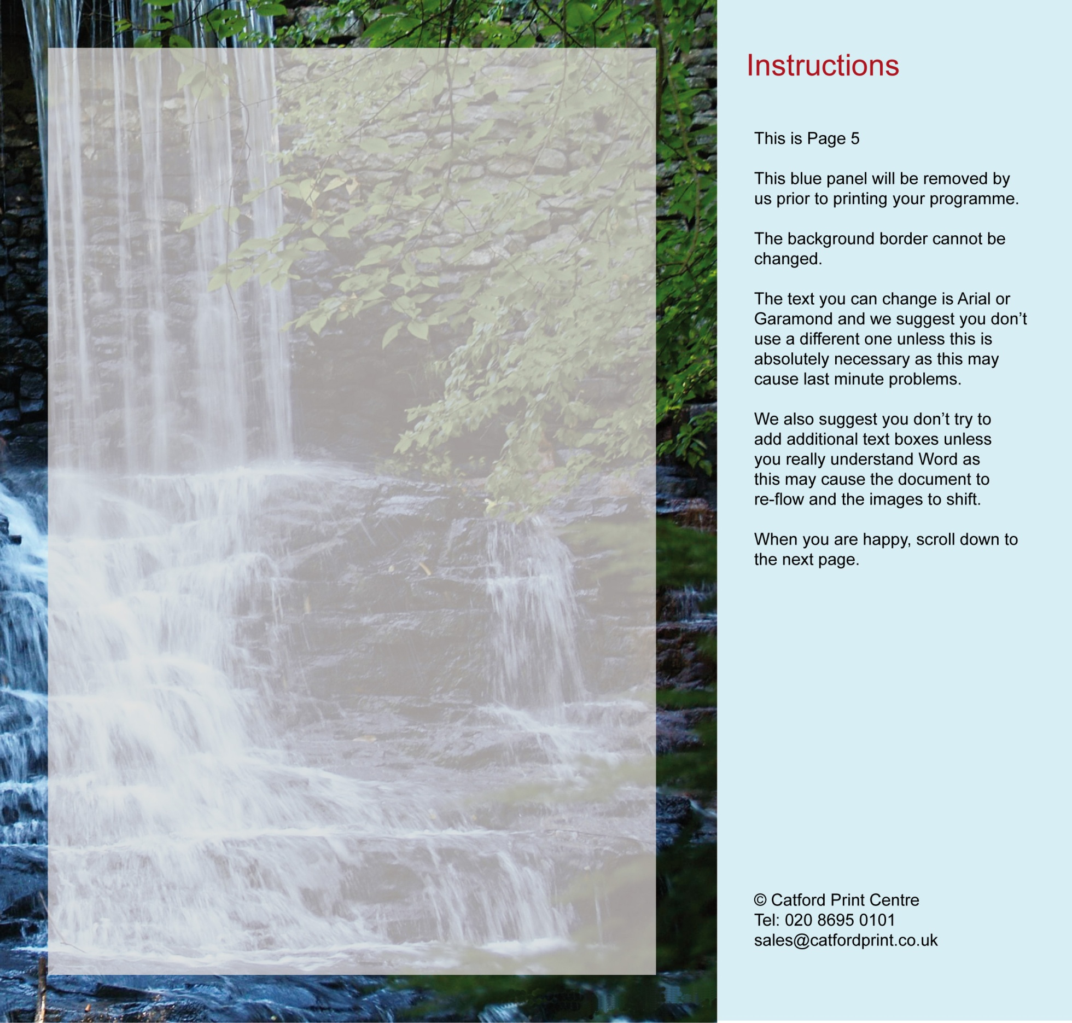
ADDRESS
~
COMMENDATION

~

2. HYMN

‘The Lord is my Shepherd’

~

COMMITTAL

~

PRAYERS & BLESSING

~

EXIT MUSIC

‘Clair De Lune’
(Claude Debussy)

2. Hymn
The Lord’s my Shepherd
The Lord’s my Shepherd, I’ll not want;
he makes me down to lie
in pastures green; he leadeth me
the quiet waters by.
My soul he doth restore again,
and me to walk doth make
within the paths of righteousness,
e’en for his own name’s sake.
Yea, though I walk through death’s dark vale,
yet will I fear none ill;
for thou art with me, and thy rod
and staff me comfort still.
My table thou hast furnished
in presence of my foes;
my head thou dost with oil anoint,
and my cup overflows.
Goodness and mercy all my life
shall surely follow me;
and in God’s house for evermore
my dwelling-place shall be.
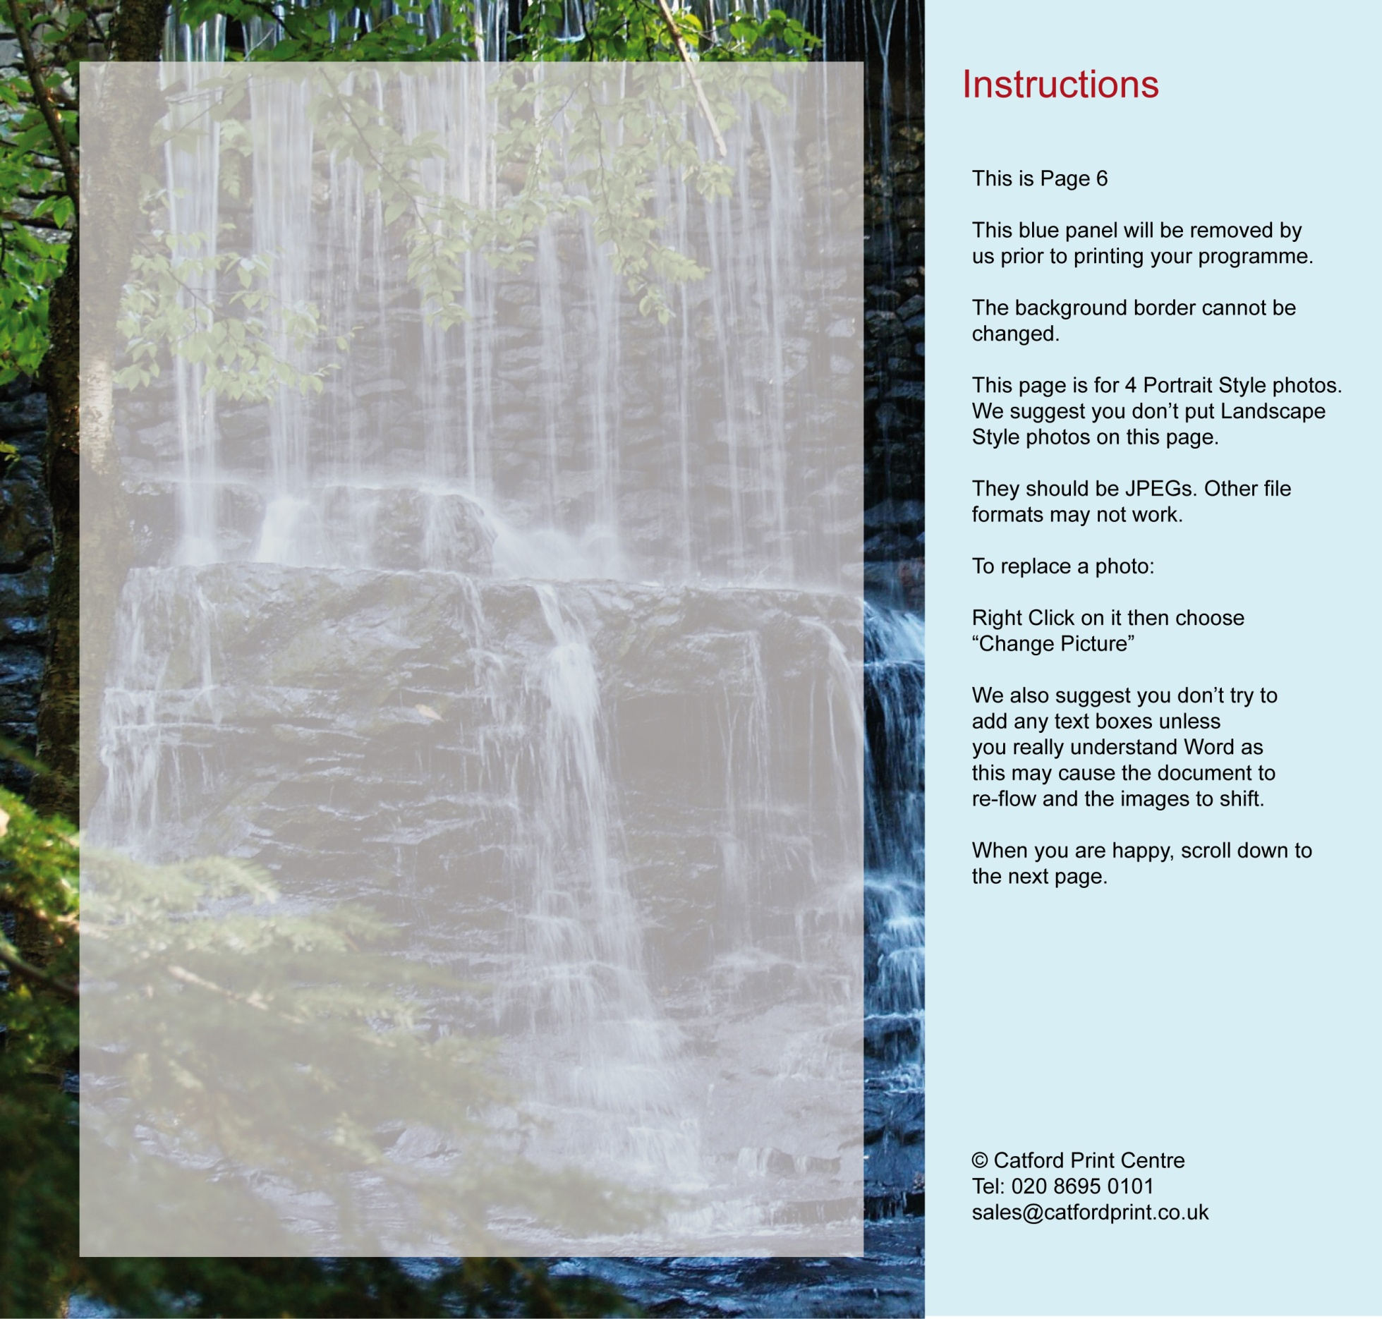
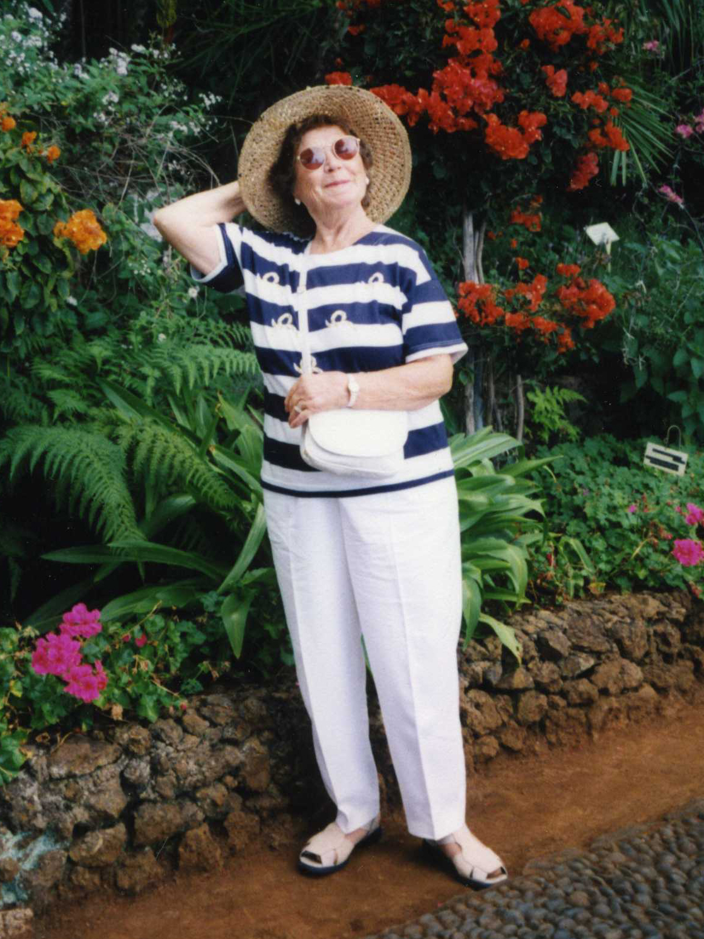
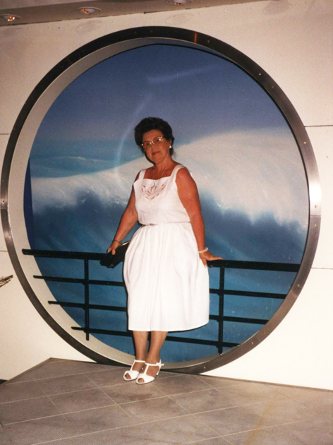
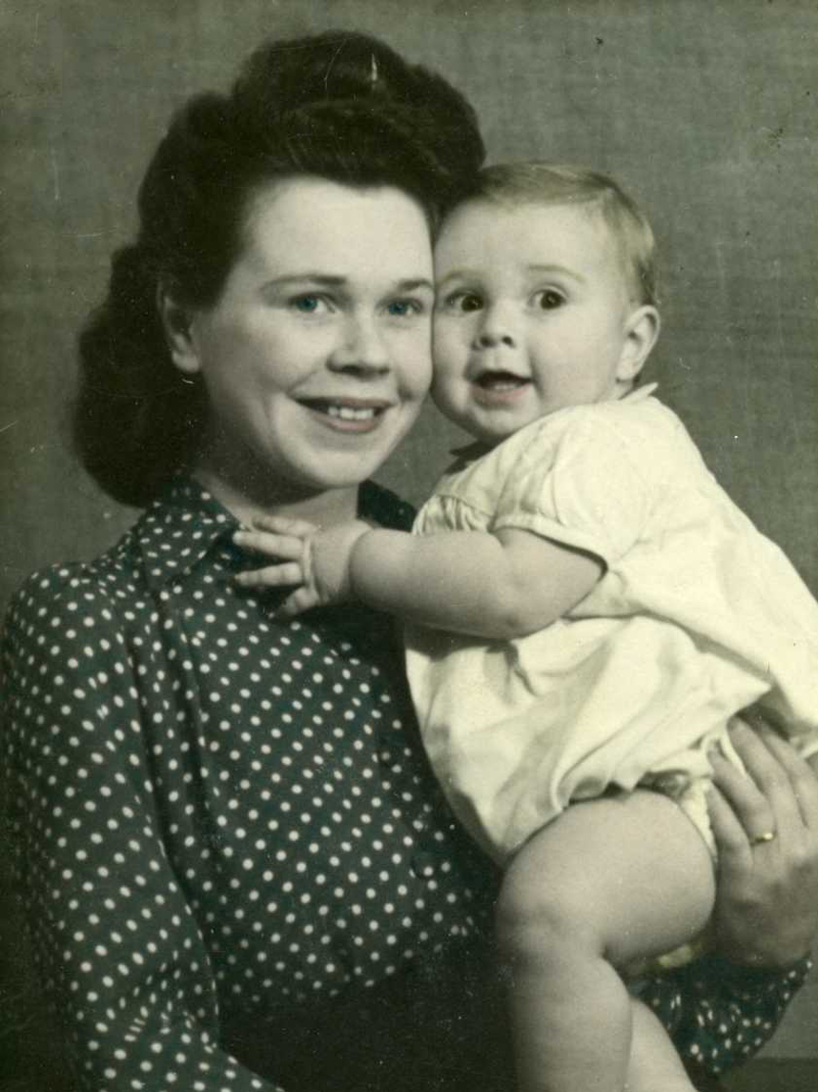
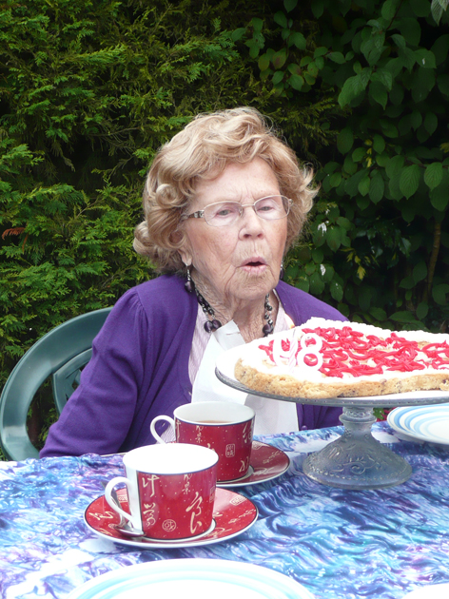

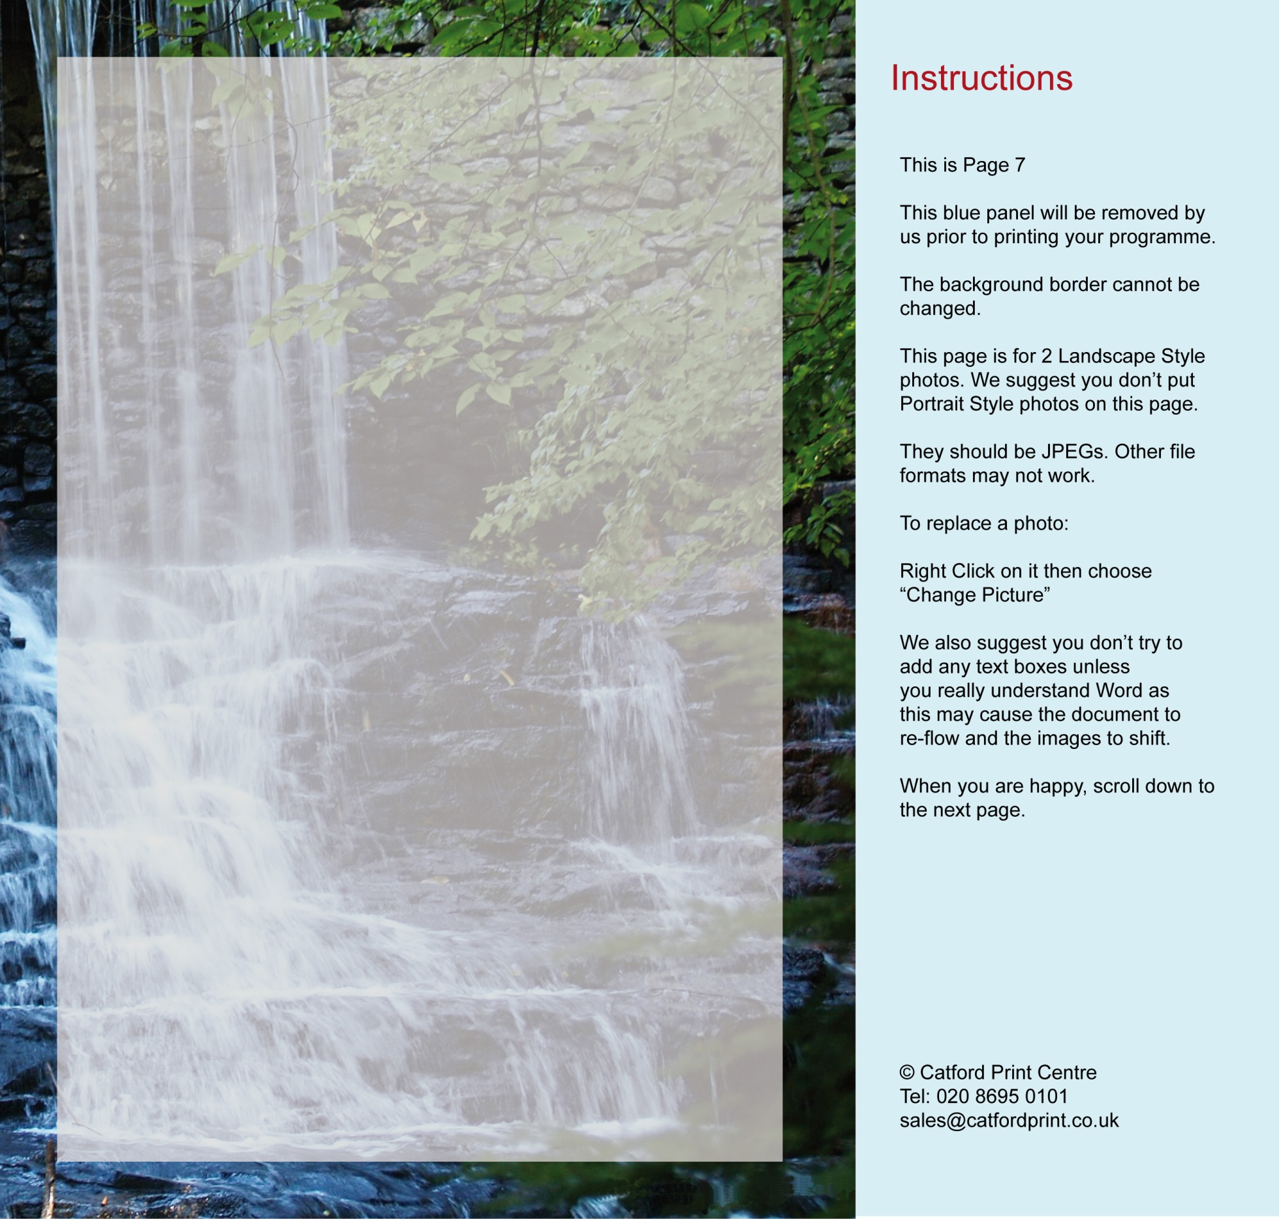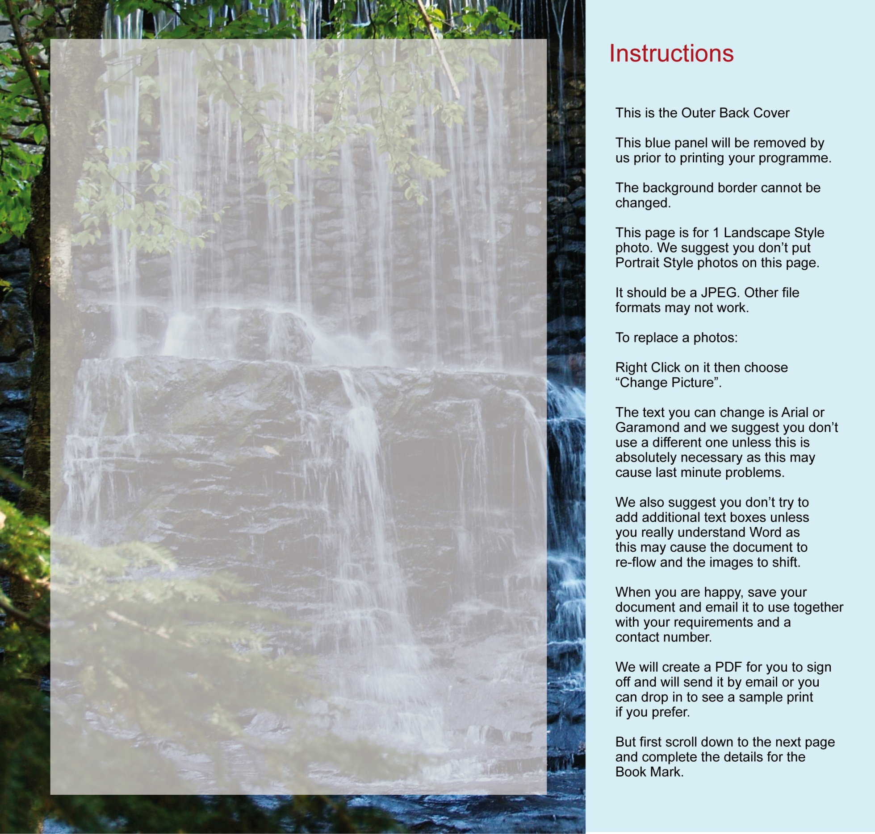
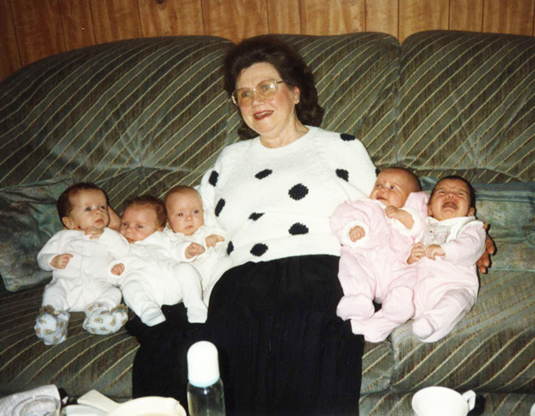
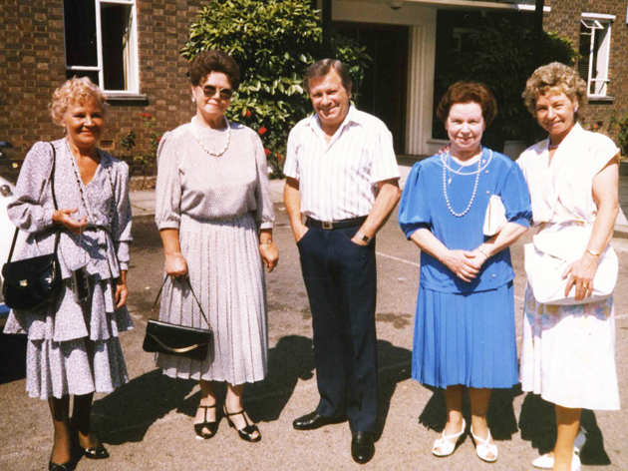
Frances’ family would like to thank you for coming to celebrate her life today and would like you to join them for refreshments at :

The William IV Public House
116 Croydon Road
Elmers End
Beckenham BR3 4DF
Frances was a wonderful wife, mother, grandmother, sister and daughter. Above all, she was my best friend and I will miss her forever. Howard xxx
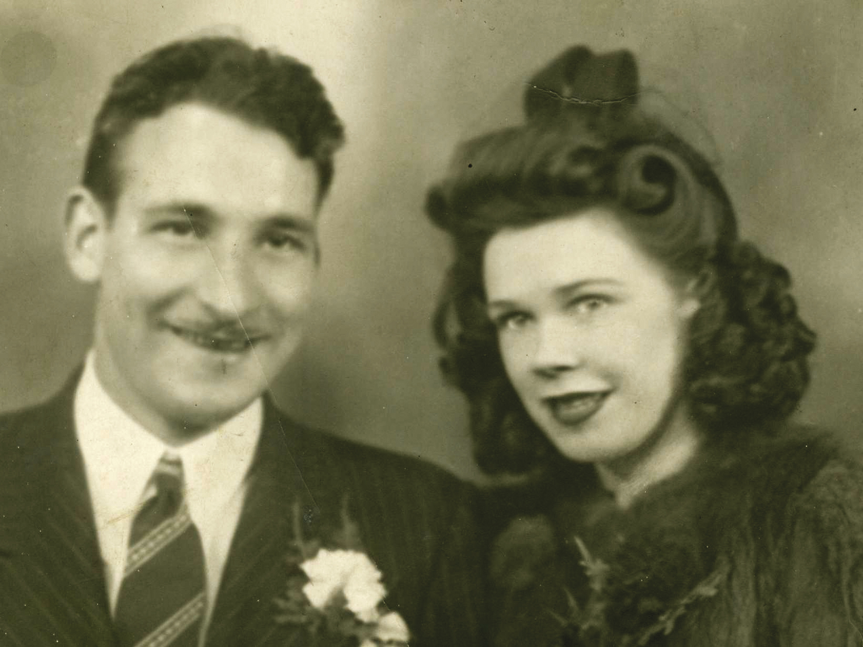
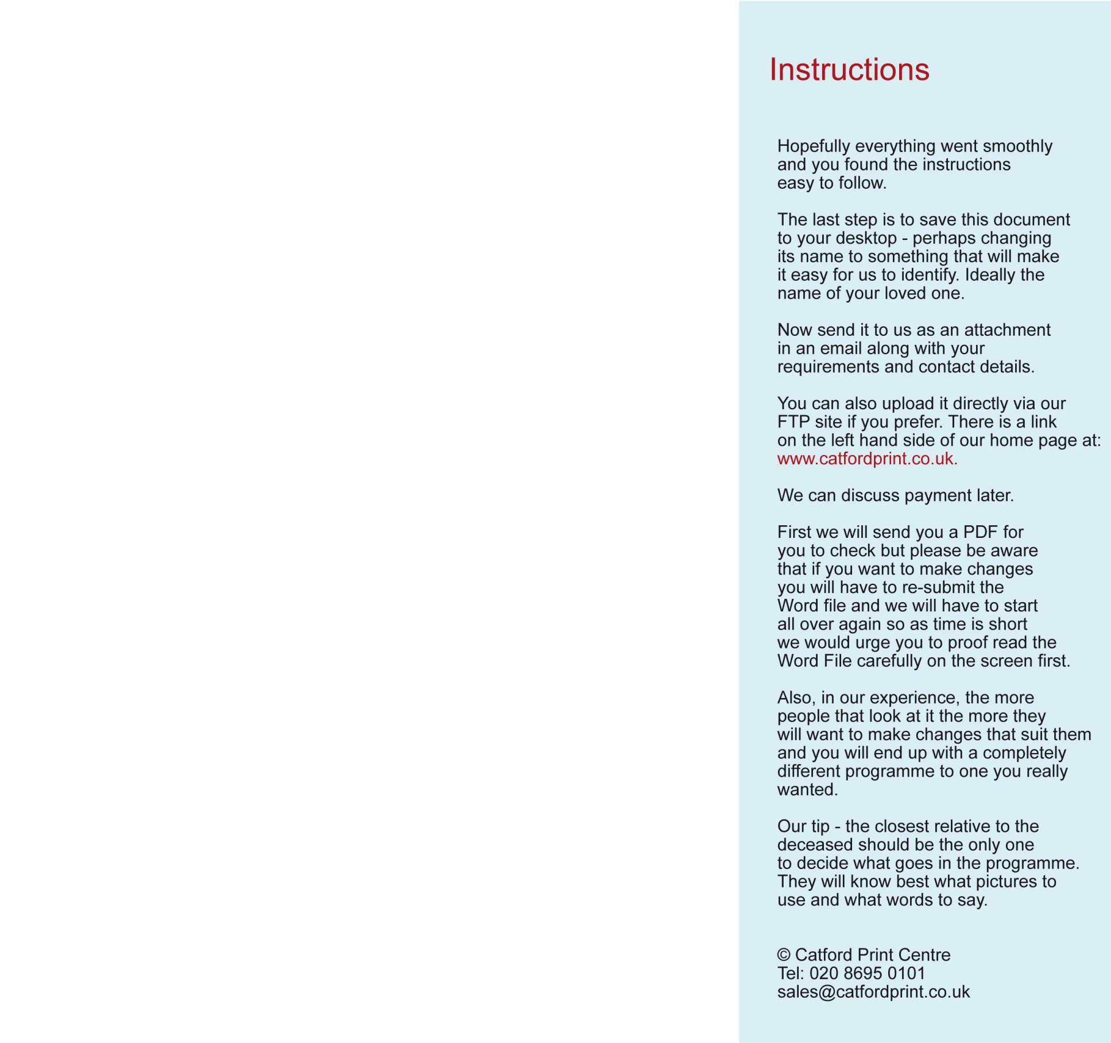
And Finally .......

